Exercise 1 part(ii):
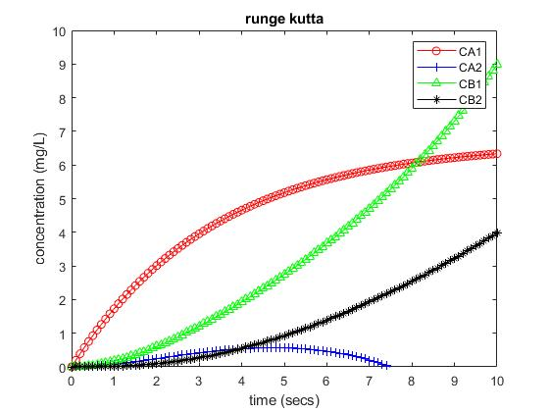
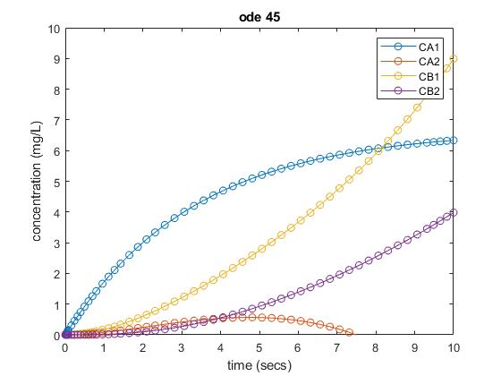

Superimposing bot graphs:
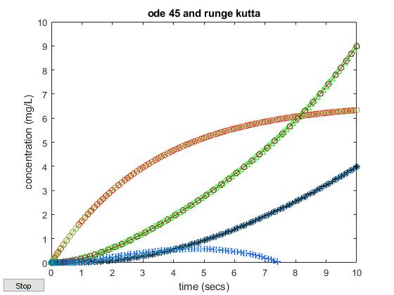
By looking at the superimpose graph, both methods, runge kutta and ode45, gave the same result. The concentration of A in the outlet of reactor 1 (A1) grows over time. The concentration of A in the outlet of reactor 2 (A2) start growing slowly and then decreases to zero after 7 minutes. The concentration of of B at the outlet of both reactors (B1 and B2) grows over time, with the concentration of B at the outlet of reactor 1 growing faster than the concentration of B at the outlet of reactor 2 (B2). By the results of ode45 and runge kutta, we can hypothesize that the concentration of A at the outlet of reactor 1 approaches a steady state as time keeps growing.

Code:

function chemical_reactor_example

% chemical reactor problem
c0 = [0; 0; 0; 0]; % initial condition
t = [0:0.1:10];
[c] = runge_kutta(@chemical_reactor,t,c0);
c1=c(1,:);
c2=c(2,:);
c3=c(3,:);
c4=c(4,:);

% runge kutta:
figure(1)
plot(t,c1,'-ro',t,c2,'-b+',t,c3,'-g^',t,c4,'-k*');
legend('CA1','CA2','CB1','CB2');
xlabel('time (secs)');
ylabel('concentration (mg/L)');
title('runge kutta')
hold off;
ylim([0,10])
% ode 45:
figure(2)
ode45(@chemical_reactor,[0 10],c0)
legend('CA1','CA2','CB1','CB2');
title('ode 45')
xlabel('time (secs)');
ylabel('concentration (mg/L)');
ylim([0,10])

figure(3)
plot(t,c1,'-ro',t,c2,'-b+',t,c3,'-g^',t,c4,'-k*');
xlabel('time (secs)');
ylabel('concentration (mg/L)');
hold on
ode45(@chemical_reactor,[0 10],c0)
title('ode 45 and runge kutta');
ylim([0,10])

return

% chemical_reactor function
function [dcdt] = chemical_reactor(t,c)
dcdt = zeros(4,1); % 4 equations
dcdt(1)=(1/5)*(10-c(1))-0.1*c(1);
dcdt(2)=-(1/5)*c(3)+0.1*c(1);
dcdt(3)=(1/5)*(c(1)-c(2))-0.1*c(2);
dcdt(4)=(1/5)*(c(3)-c(4))+0.1*c(2);

return

function [y] = runge_kutta(df,x,y0)
m = length(y0);
n = length(x);
% y is a matrix of size 'mxn'
y=zeros(m,n);
y(:,1)=y0;
for i=1:n-1
h = x(i+1)-x(i);
xi=x(i);
yi=y(:,i);
k1 = feval(df,xi,yi);
k2 = feval(df,xi+0.5*h,yi+0.5*k1*h);
k3 = feval(df,xi+0.5*h,yi+0.5*k2*h);
k4 = feval(df,xi+h,yi+k3*h);
y(:,i+1) = y(:,i) + h*(k1+2*k2+2*k3+k4)/6;
end
return

